**IBM Nalaiya Thiran**

**IBM-Project-11124-1659267524 - ASSIGNMENT - 2**

**Name: Sudharsanan M**

**Roll no:** 19BCS080

**Project: Corporate Employee Attrition Analytics**

**Exploring, visualizing and creating Dashboard for the Pharma dataset:**

**Sales By Customer:**

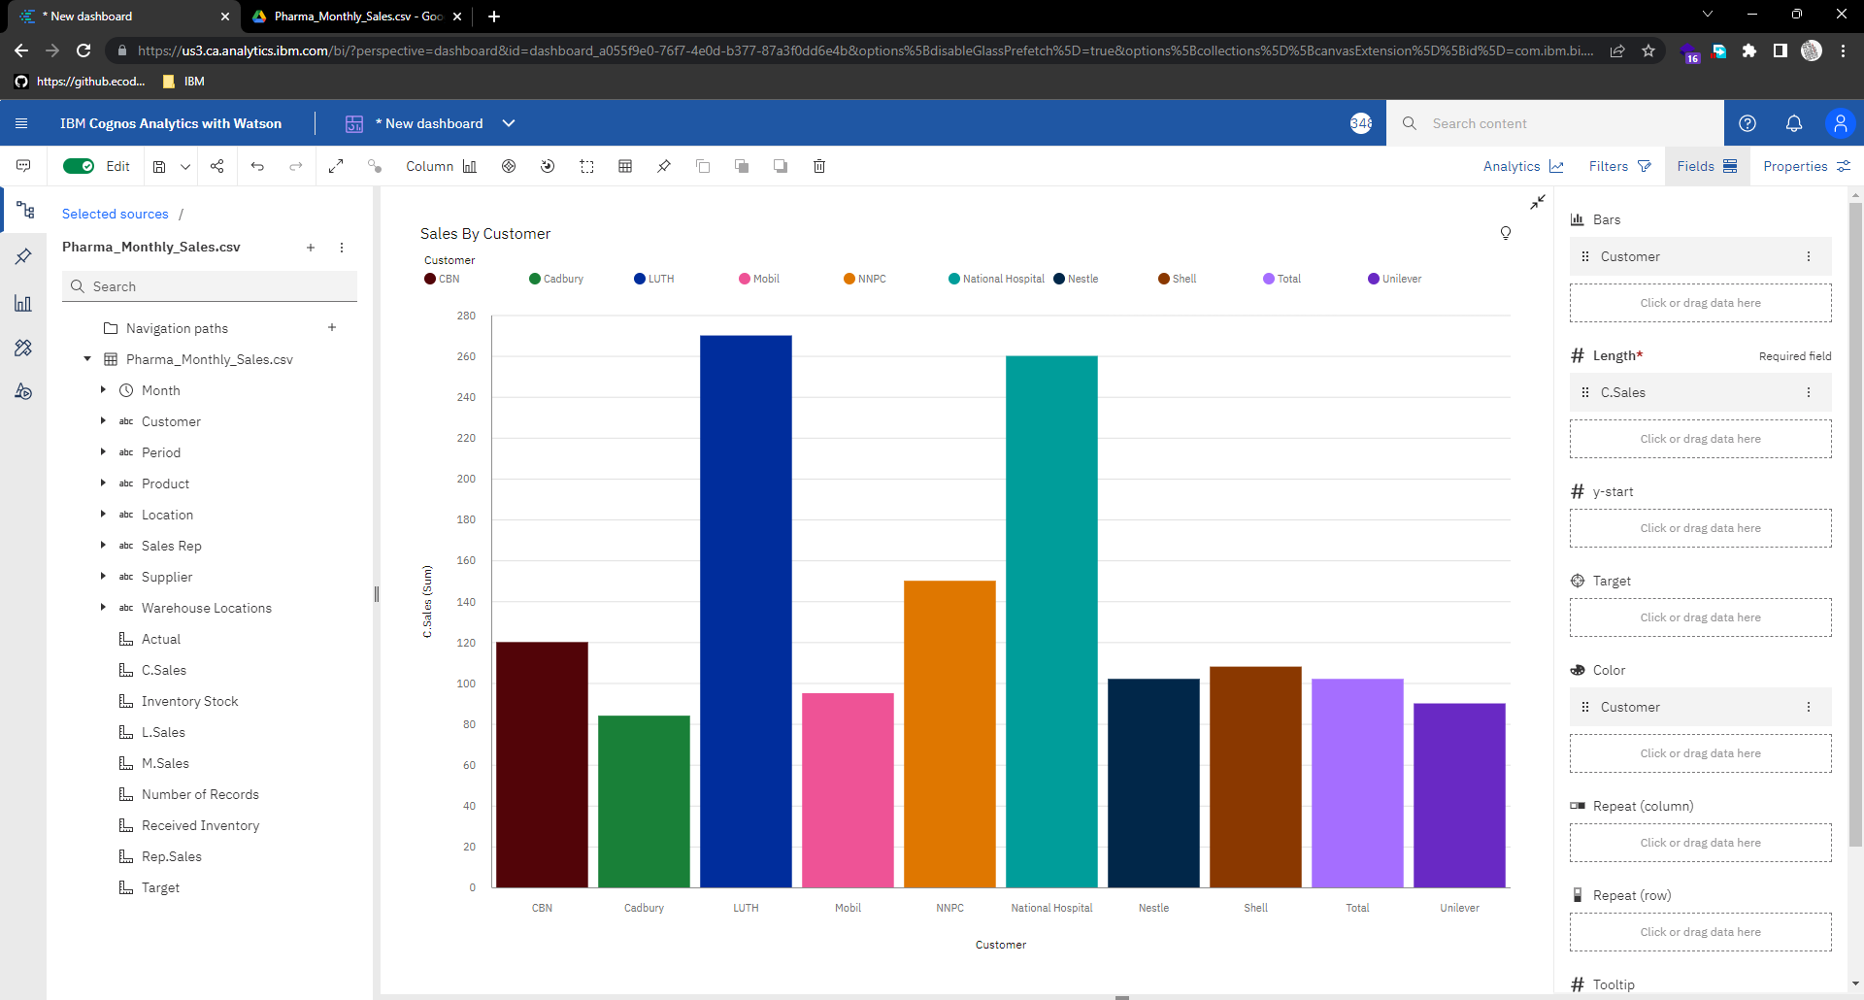

**Sales By Location:**

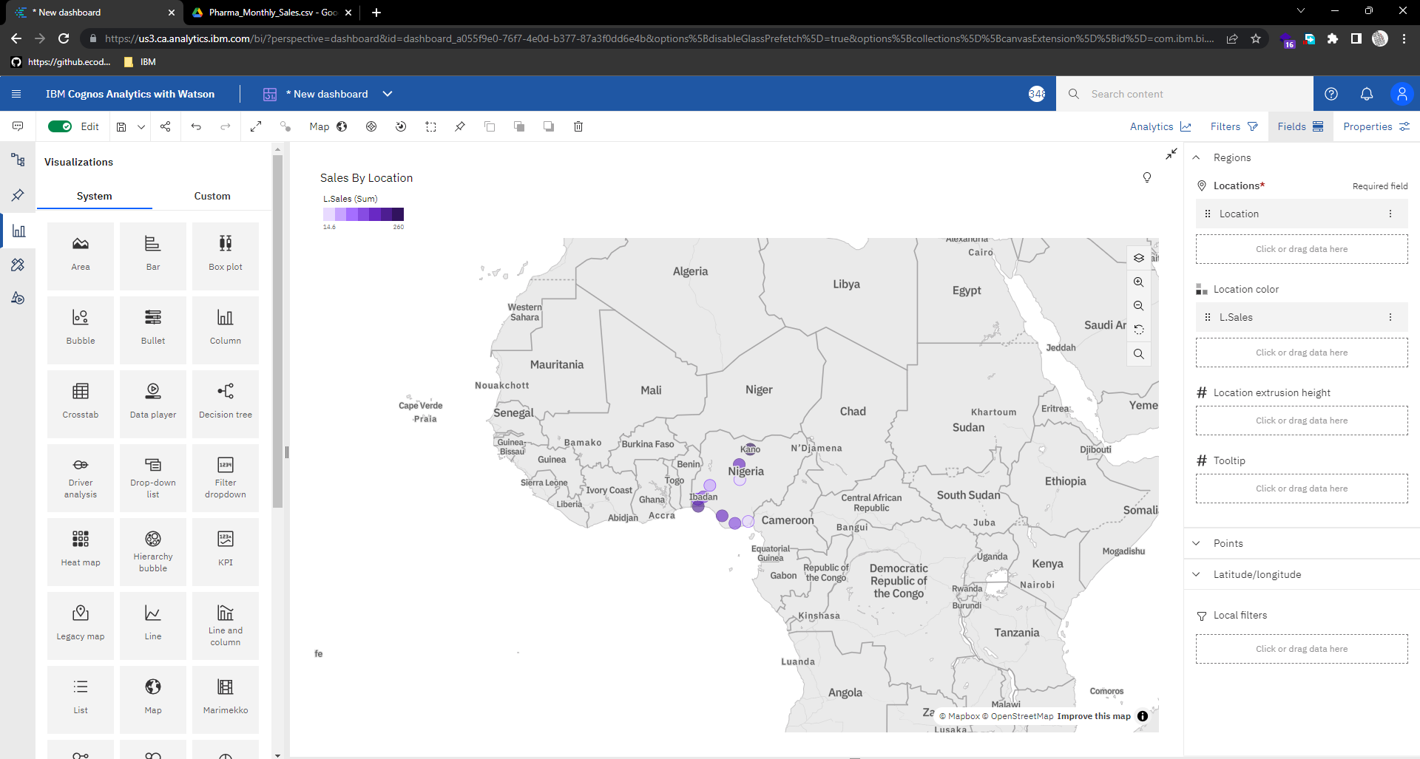

**Sales By Sales Representative:**

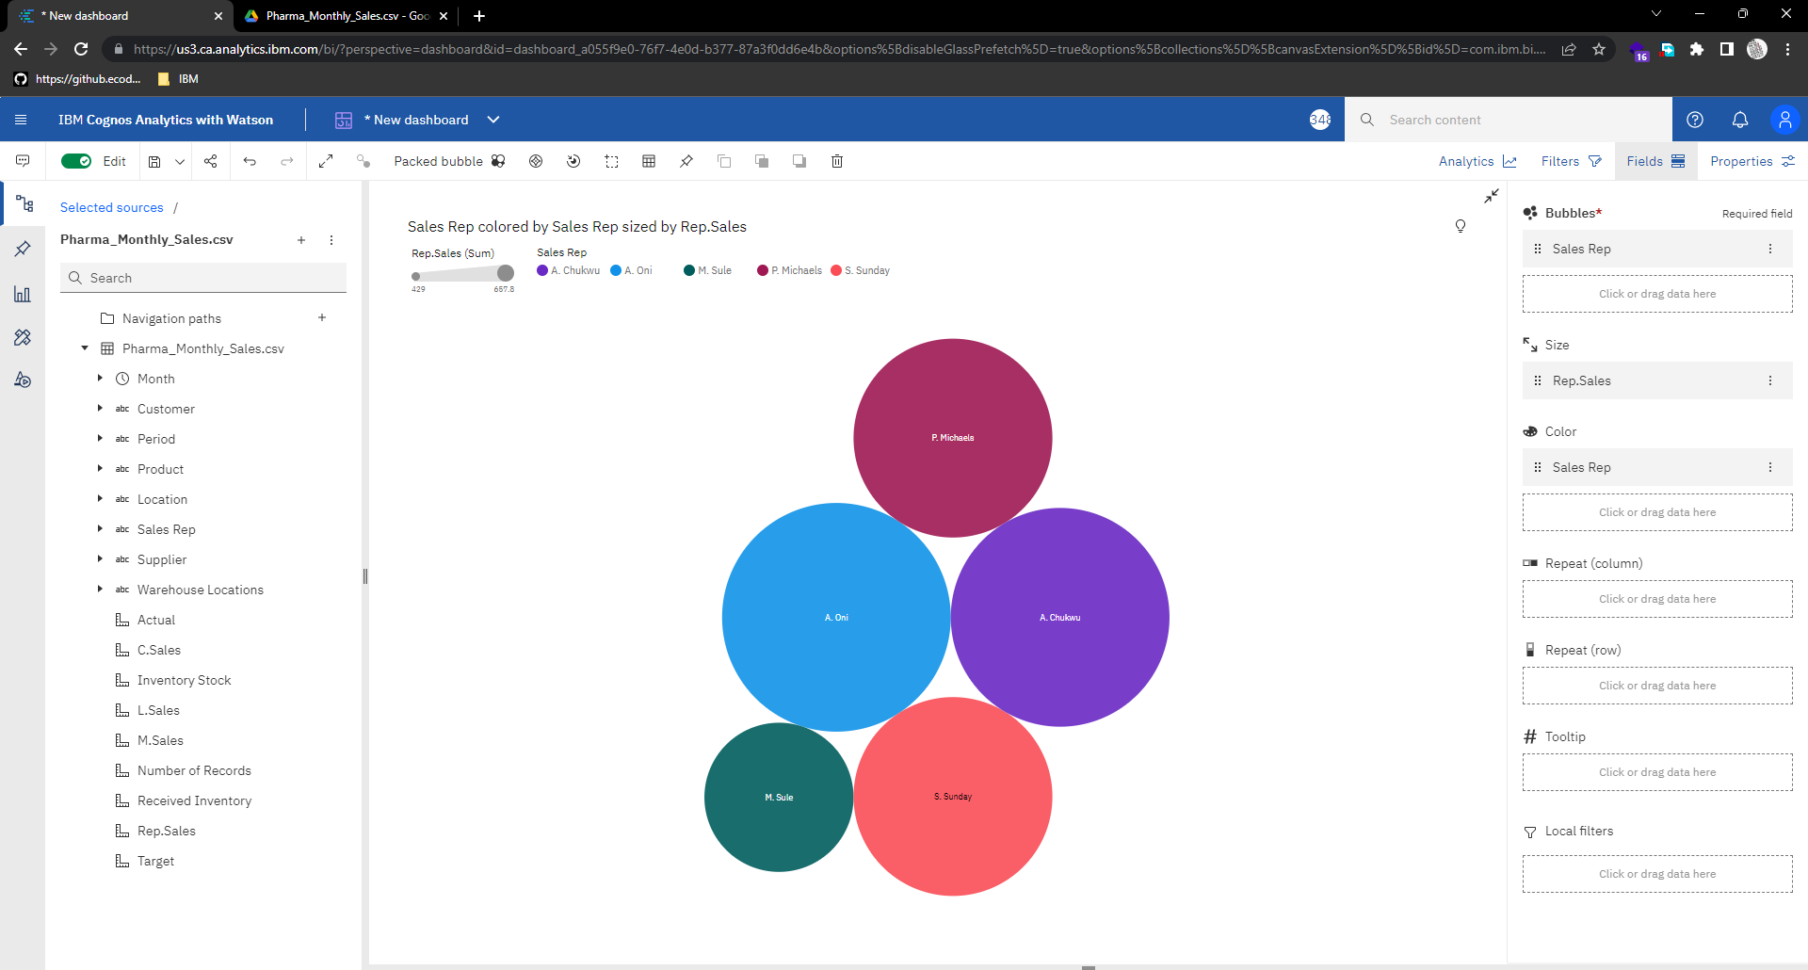

**Received Inventory from Supplier:**

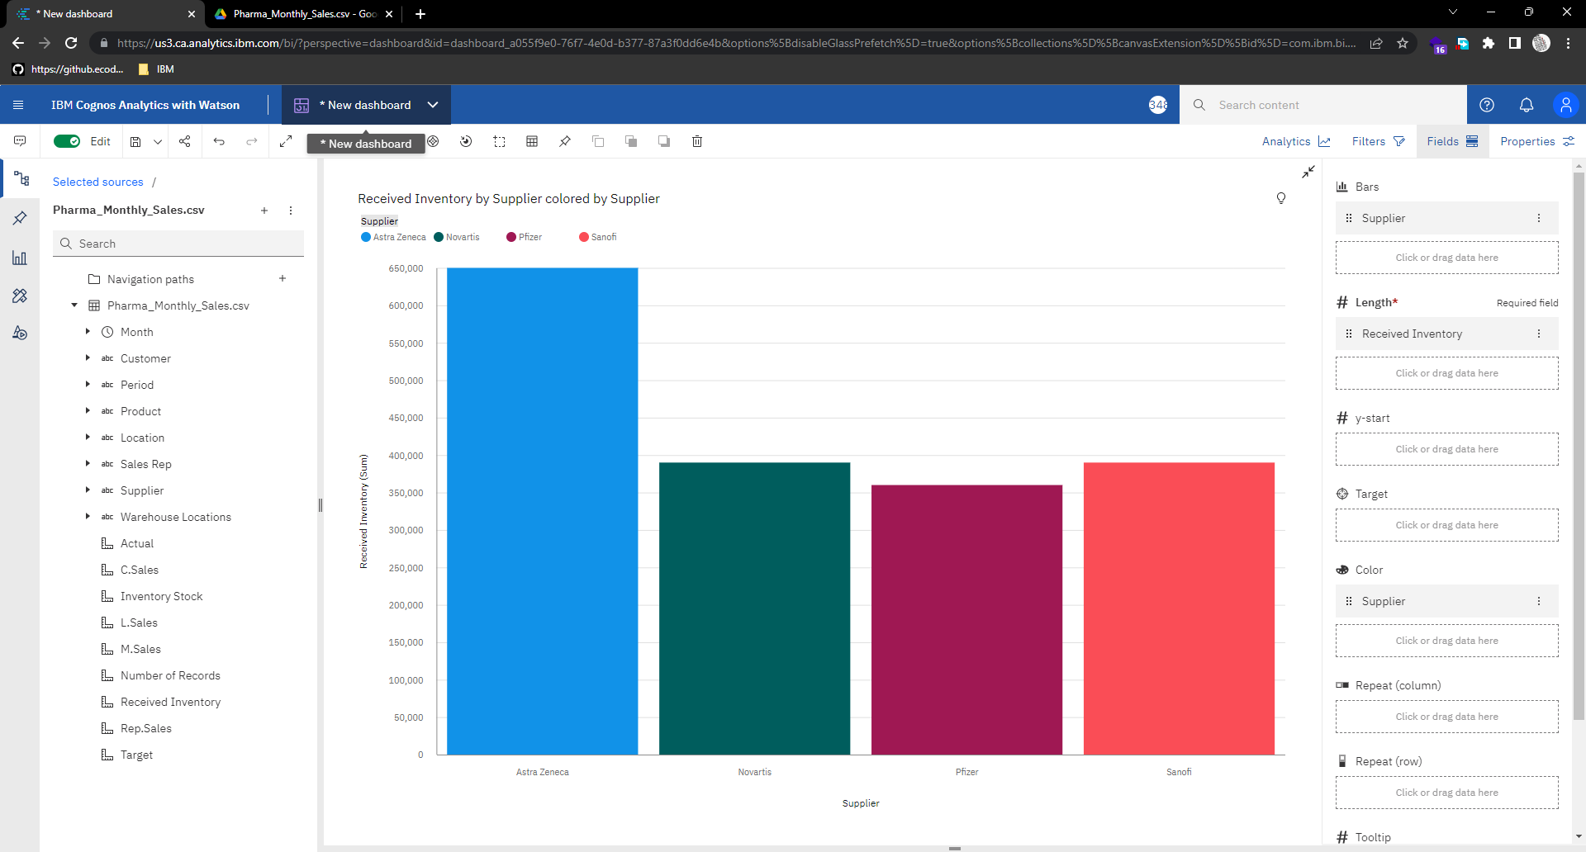

**Sales Trend:**

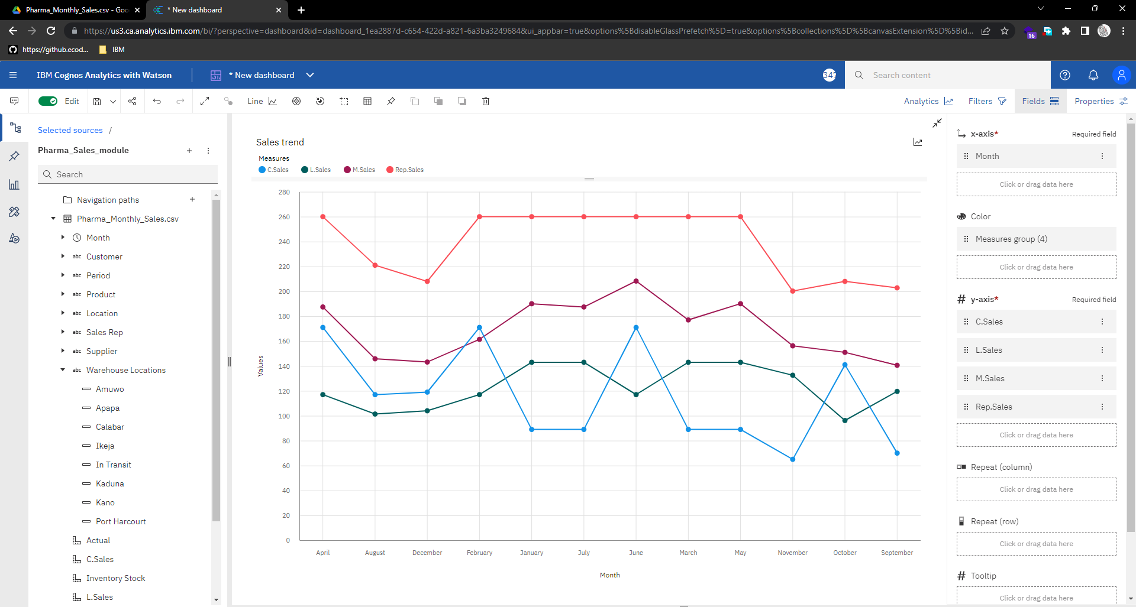

**Inventory Stock for Warehouse Locations:**

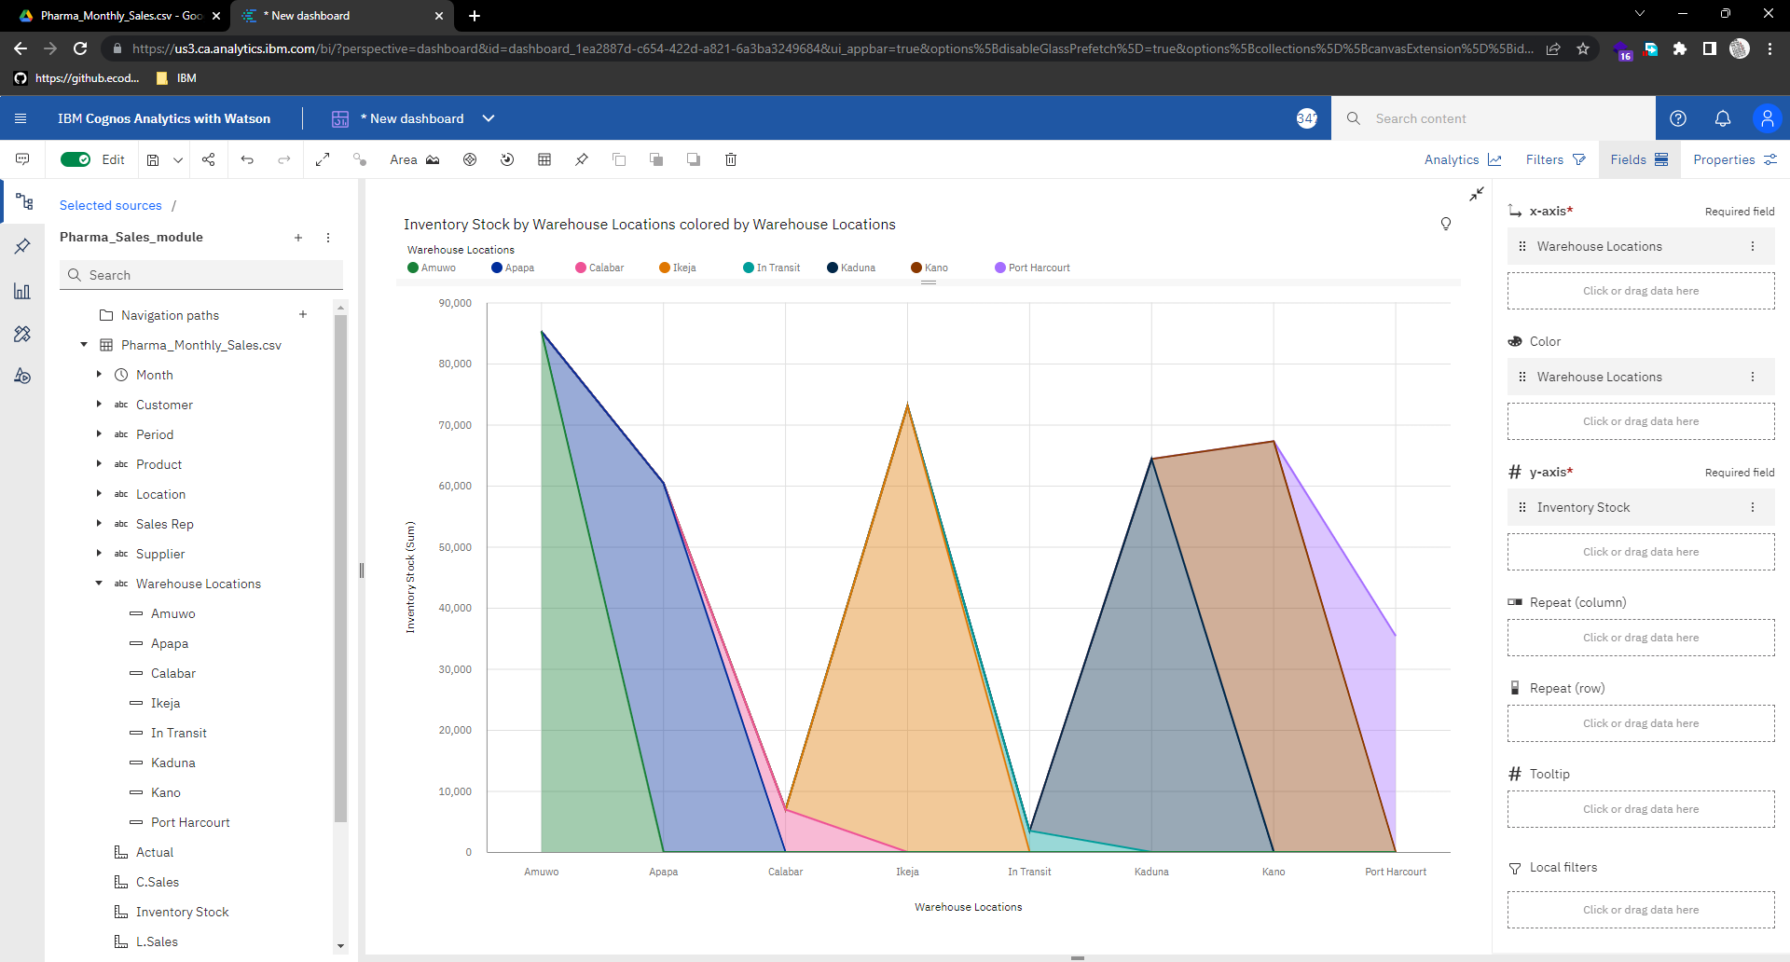

**Monthly Sales:**

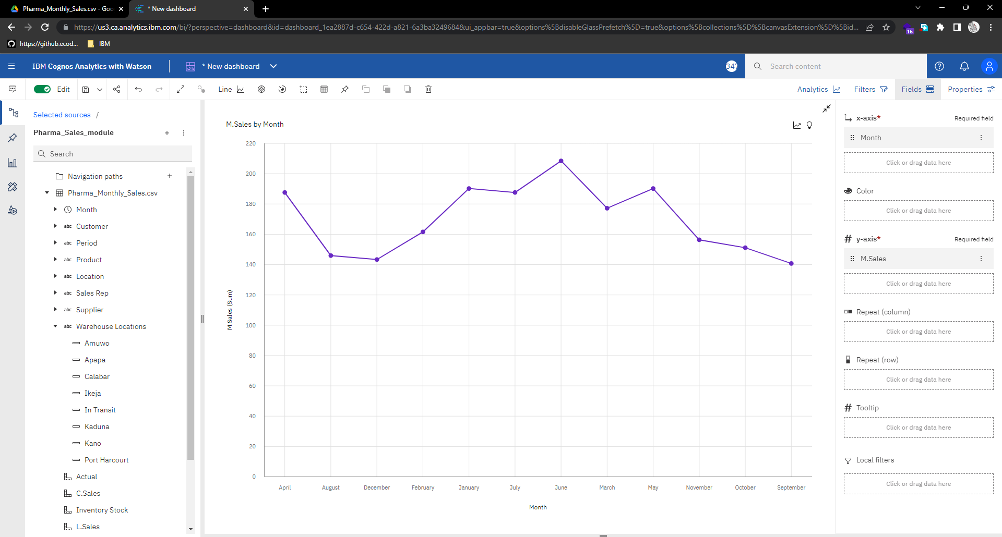

**Actual and Received Inventory by Month**﻿:

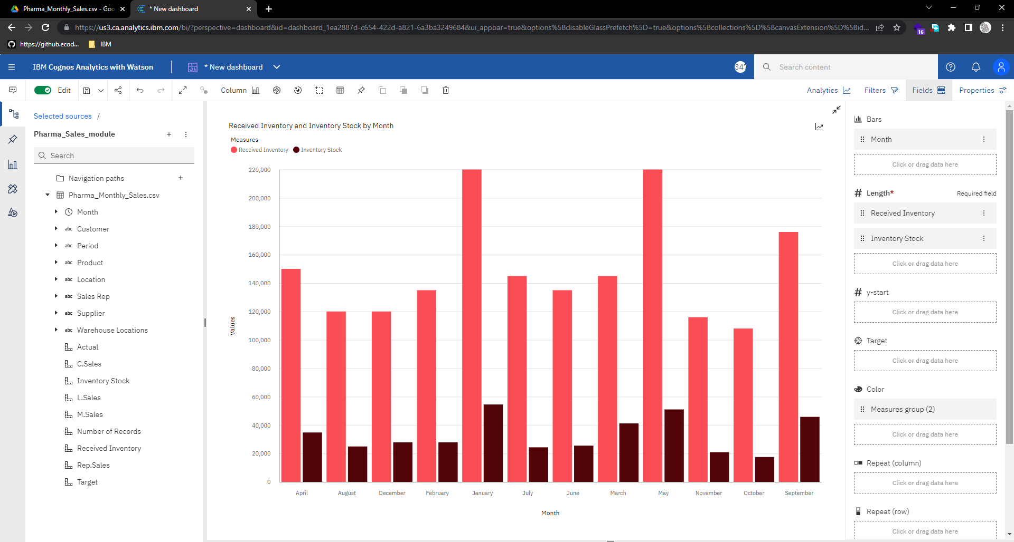

**Dashboard:**

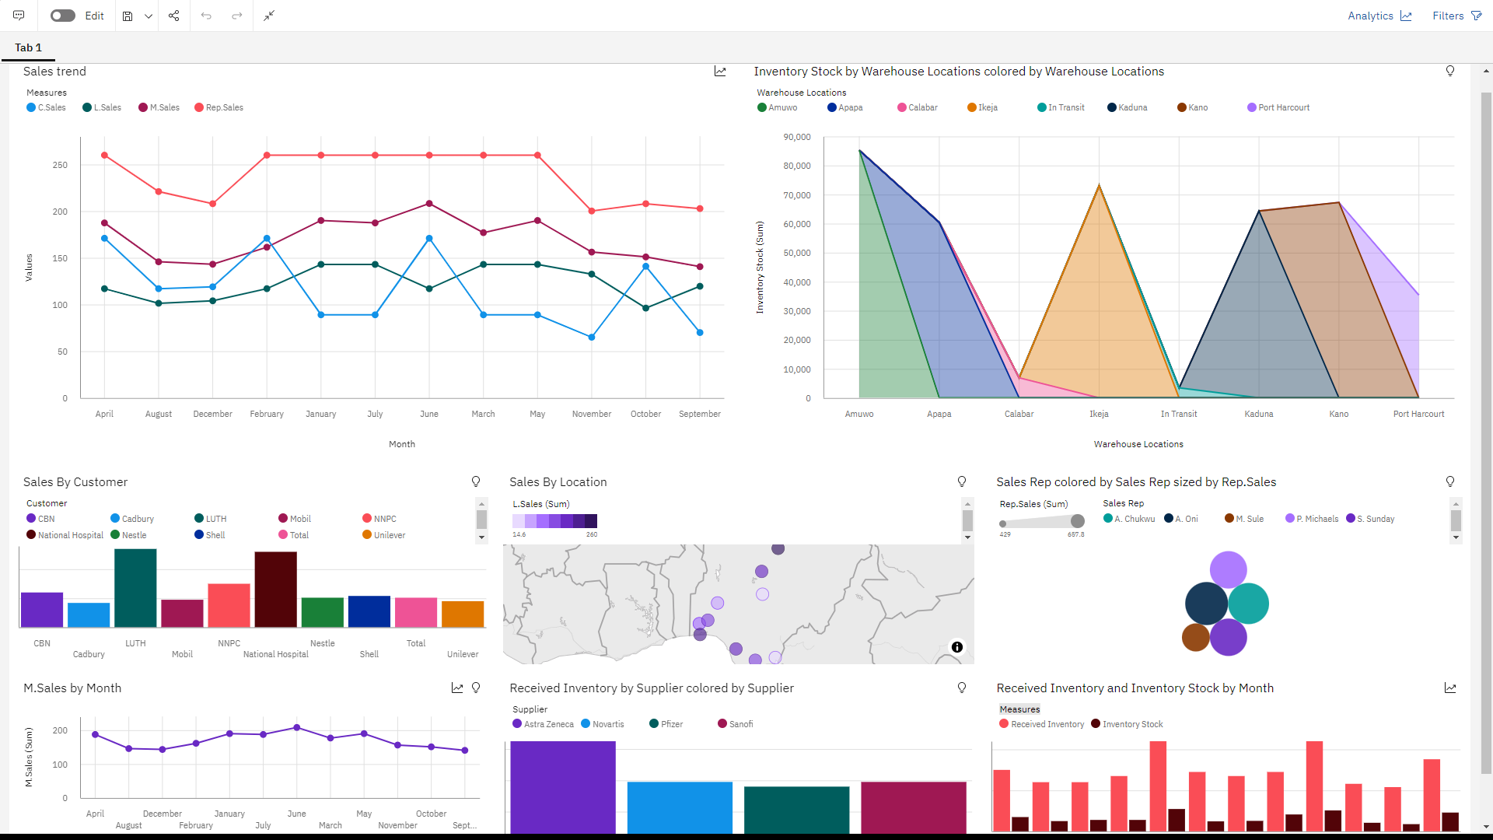

**Dashboard Link:**

<https://us3.ca.analytics.ibm.com/bi/?perspective=dashboard&pathRef=.my_folders%2FPharma%2BSales%2BDashboard&action=view&mode=dashboard&subView=model0000018389fcb316_00000001>